## Exp :**Design a system for a red colored magical heart pendant that blinks 60 times a minute and stops blinking and turns blue during night.**

Circuit Diagram: 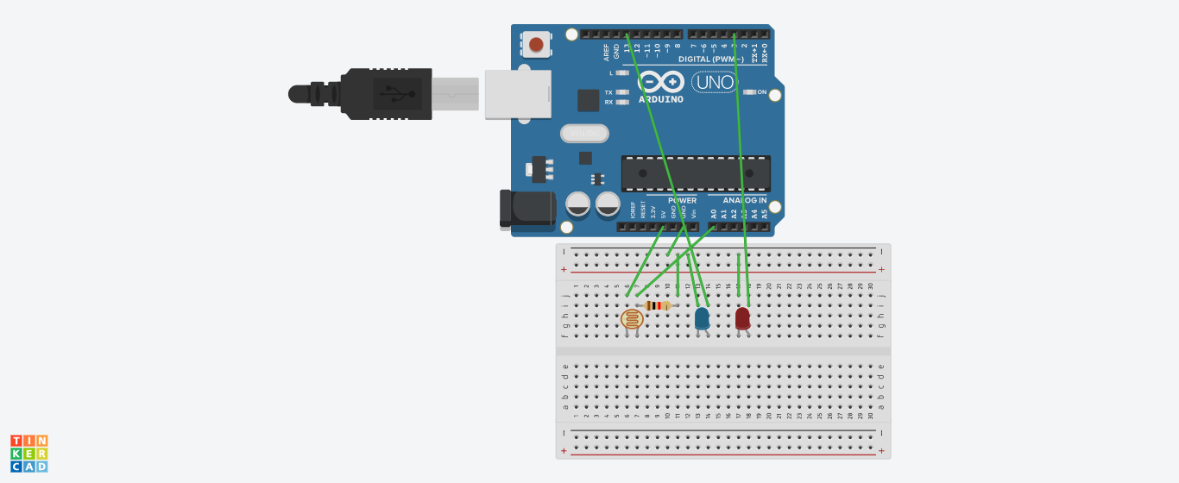

## **Concept Used** : blink LED 60 times a minute and stops blinking and turns blue during night.

Learning & Observations:

The LED light glow of different colours at different period of time

Problems & Troubleshooting:

1. Problem in fixing wire from bread board to arduino.
2. Problem in doing arduino programming.
3. Problems in understanding the logic.

Precautions:

1. Correct connection of negative and positive terminal of led.
2. Don’t put arduino near water.
3. Check the USB port of computer is working.
4. Check the arduino software and select the correct port (in which arduino is connected).

Learning Outcome:

1. LED light glow of different colours at different speed at different brightness of surroundings.
2. Arduino function as a controller in led’s.
3. Bread board is used to organize the circuit.

**CODING:**

const int ledPin=13;

const int ldrPin=A0;

void setup() {

Serial.begin(9600);

pinMode(ledPin,OUTPUT);

pinMode(ldrPin,INPUT);

pinMode(3,OUTPUT);

}

void loop() {

int ldrStatus=analogRead(ldrPin);

if(ldrStatus<=10) {

digitalWrite(ledPin,HIGH);

}

else if(ldrStatus>=500)

{

digitalWrite(ledPin,LOW);

digitalWrite(3,HIGH);

delay(500);

digitalWrite(3,LOW);

delay(500);

}

}